**A PROJECT REPORT ON**

AIML CHATBOT

**BY**

**Mahajan Shreyas (12005)**

**Pawar Akshay (12004)**

**IN PARTIAL FULFILLMENT OF**

**M.Sc.(Computer Science) Part I**

**SIR PARASHURAMBHAU COLLEGE, PUNE**

**(2018-2019)**

**ACKNOWLEDGEMENT**

We have great pleasure in presenting this project entitled “Aiml ChatBot”. We thankfully acknowledge the help that we have obtained from teachers of COMPUTER SCIENCE DEPARTMENT for their support and co-operation right from the stage the project was conceived.

The journey of this project from conception to completion was possible due to **Ms. Kanchan Deshpande** for giving us valuable information about the implementation of the project.

A special thanks to  **Ms. Madhuri Deshpande** madam (Head of Comp.Sci.Dept.) for this help and providing us good laboratory facility.

A special thanks to Mr. Kunal Pagariya (Industry Faculty) for his help.

Last but not least, we would like to express our sincere gratitude to those who have helped us directly or indirectly in our project.

Index

1. Introduction.........................................................................................................................4

2. Problem Description............................................................................................................5

3. Scope of the Work (Modules)………….............................................................................5

4. Feasibility Study ................................................................................................................6

4.1Economical Feasibility

4.2 Operational Feasibility

4.3Technical Feasibility

5. Requirement Analysis………............................................................................................7

6. Data Dictionary………………………………………………….……………………….7

7. UML Diagrams…………………………….…………………………………………….8

7.1 Use Case Diagram….…………................................................................................8

7.2 Class Diagram…….…………………......................................................................9

7.3 Sequence Diagram……………………………........................................................10

7.4 User Activity Diagram………..……….…...............................................................11

7.5 User Activity Diagram………..….…………...........................................................12

.

8. UI Screens.…….………………………………………………………….……………..13

9. Drawbacks.........................................................................................................................17

8. Future Enhancements........................................................................................................17

10. Bibliography ...................................................................................................................17

Introduction

A chatbot is a conversational agent where a computer program is designed to simulate an intelligent conversation. It can take user input in many formats like text, voice etc. For this purpose, many open source platforms are available. Artificial Intelligence Markup Language (AIML) is derived from Extensible Markup Language (XML) which is used to build up a conversational agent (chatbot) artificially.

Created by a team of individuals that included Dr. Richard Wallace, Thomas Ringate and others in the mid 1990's, it is a subset of XML (eXtensible Markup Language), and is used more or less as a database of input patterns/responses to draw upon to turn a user's inputs into relevant responses.

Problem Definition

Whenever we visit any shopping website, or any about page, or any website, the experience which we encounter is boring. The reason for this is that GUIs usually have a hard time providing a memorable user experience. This is where chatbots come into the picture.

Chatbot provide you with exact information that is interesting to you right now or which is more appropriate at that moment for you, and in small understandable chunks rather than all at once.

Scope of the work (Modules)

Chatbot is an AI chatbot that receives questions from users, tries to understand the question, and provides appropriate answers. It takes input from user , then going through relevant data by using pattern matching and gives a response to user. In other words, it answers your questions like a human does, instead of giving you the list of websites that may contain the answer.

Modules:

a. User : User will start a conversation by asking any question to chatbot. User can also view the total number of questions asked by him or her.

b. Chatbot: A chatter robot (chatbot) is a type of conversational agent, a computer program designed to simulate an intelligent conversation with one or more human users via auditory or textual methods.

c. Administrator: The role of the administrator is simple. He/she can only view and analyse the records.

Feasibility Study

**Economically Feasibility:** The system is economically feasible. It does not require any addition hardware or software. Since the interface for this system is developed using the existing resources and technologies, there is economical feasibility for certain. All the chosen technologies are widely used in the world and are available for free use. These technologies are all open source software (AIML,PYTHON,SQLITE3,FLASK,HTML,BOOTSTRAP) and does not require any registering or purchasing of any kind. These open source software sources are available widely and knowledge is freely available through the internet.

**Technical feasibility**: The technical requirement for the system is economic and it does not use any other additional Hardware and software. Technical evaluation must also assess whether the existing systems can be upgraded to use the new technology.

**HARDWARE REQUIREMENTS (Minimum Requirement)**

* **Minimum RAM:** 2GB or more
* **Hard Disk:-**40 GB
* **Processor:-**Intel Pentium 4 or above

**SOFTWARE REQUIREMENTS (minimum Requirement)**

* **Operating system :**Windows
* **Front Design :**HTML/BOOTSTRAP
* **Back-End:** SQLITE3,PYTHON,AIML,FLASK(FrameWork)

**Operational Feasibility:** The system working is quite easy to use and learn due to its simple but attractive interface. User requires no special training for operating the system.

Requirement Analysis:

Requirements Analysis encompasses those tasks that go into determining the needs or conditions to meet for a new or altered product or project, taking account of the possibly conflicting requirements of the various stakeholders.

Data Dictionary

|  |  |  |  |  |
| --- | --- | --- | --- | --- |
| S.No | Field Name | Data type | Constraints | Description |
| 1 | ID | Int | Primary Key | Auto Increment |
| 2 | First Name | Text | Not null | User First Name |
| 3 | Last Name | Text | Not null | User Last Name |
| 4 | Email Id | Text | Not null | User’s email address |
| 5 | Password | Text | Not null | User Password |
| 6 | Que_cnt | Int | Not Null | Total number of questions asked |

UML DIAGRAMS

Use Case:

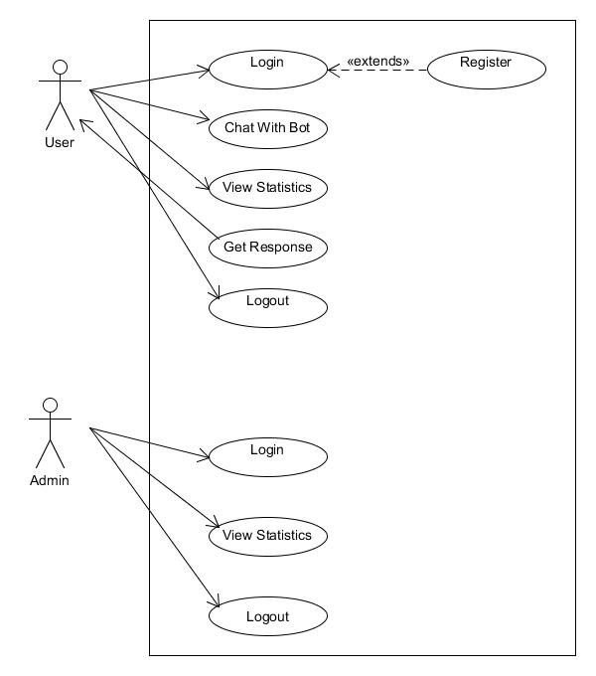

Class Diagram:

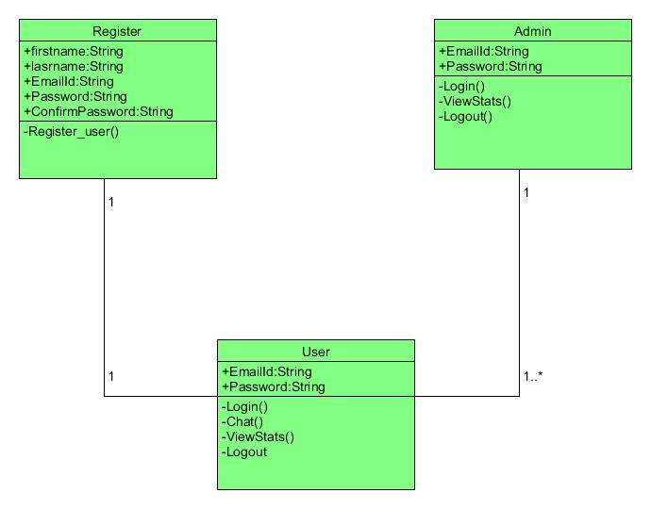

Sequence Diagram:

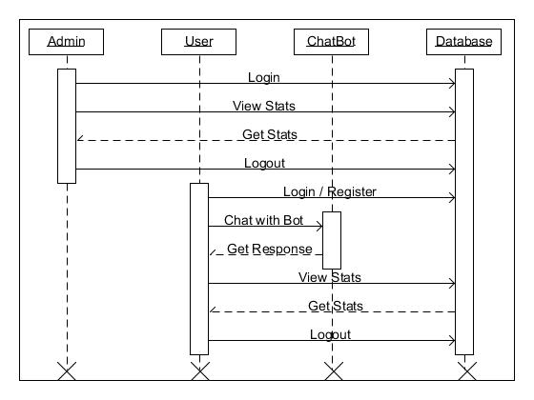

Activity Diagram:

User’s Activity Diagram:

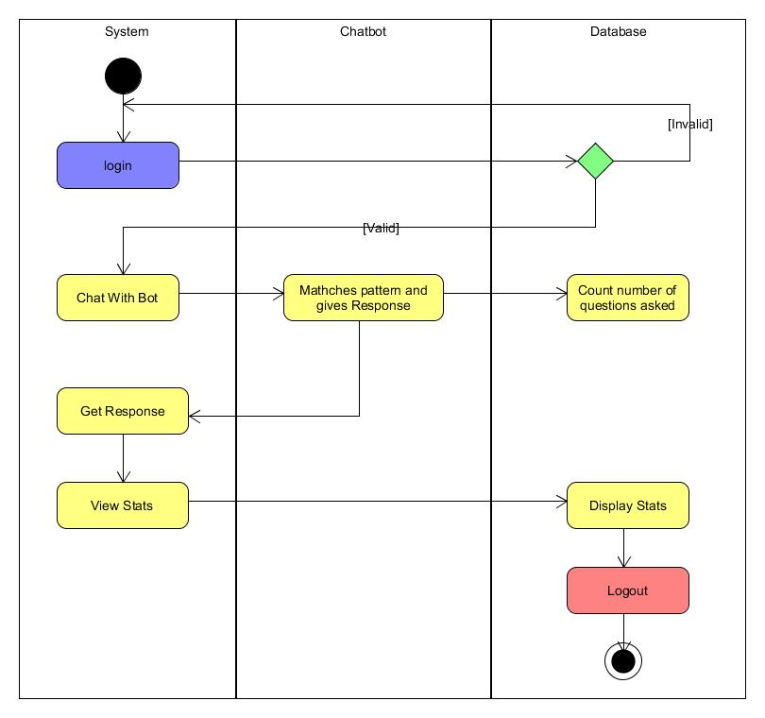

Admin’s Activity Diagram:

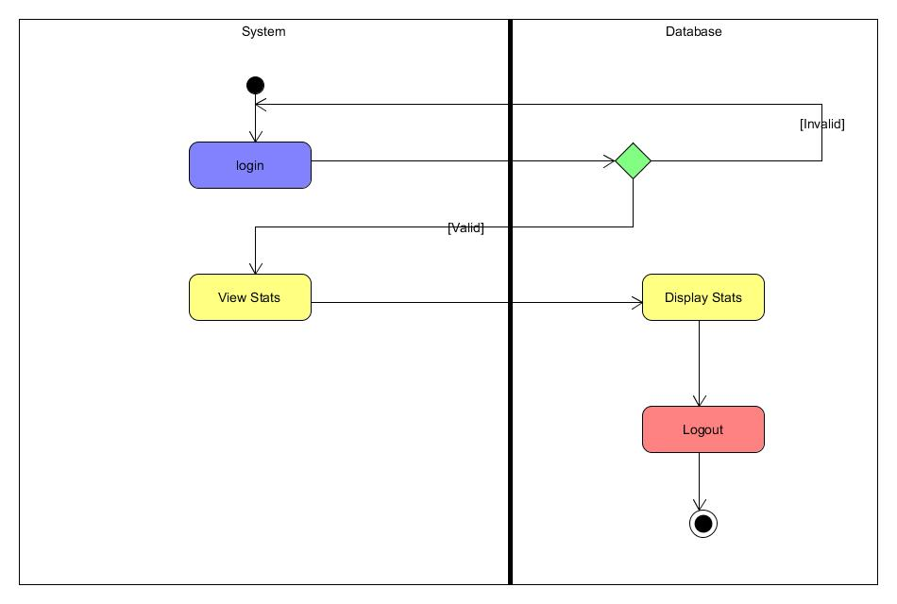

UI SCREENS

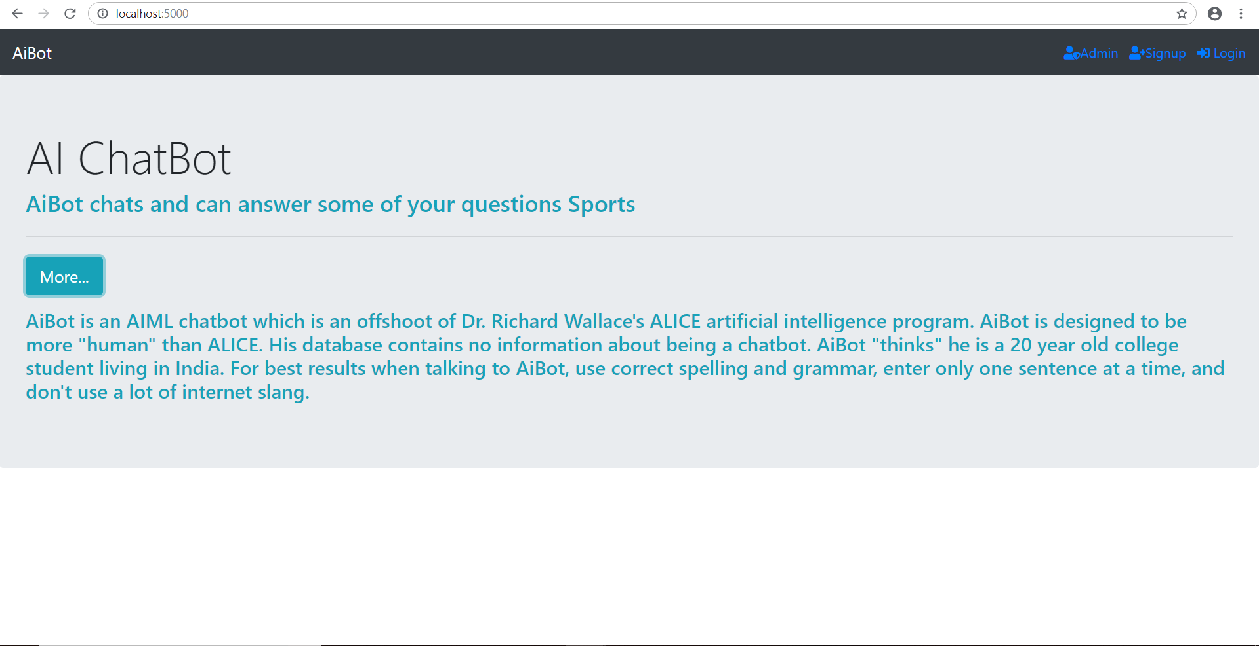

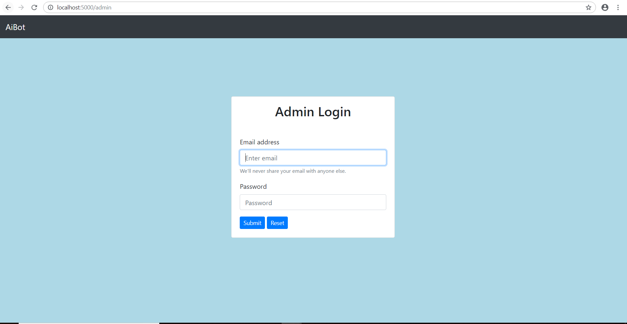

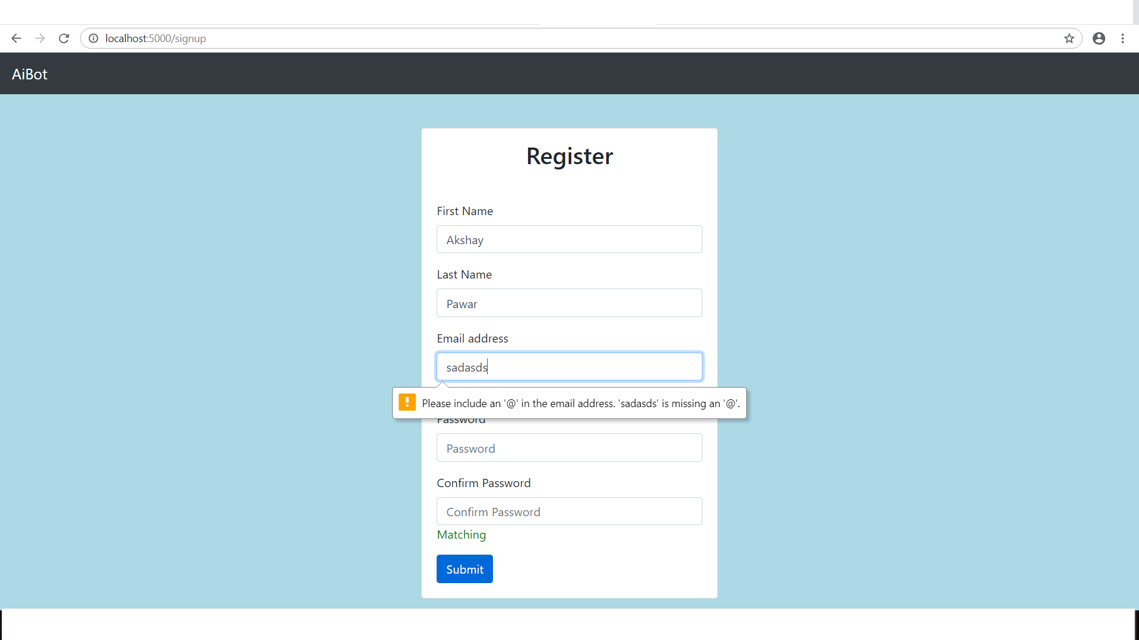

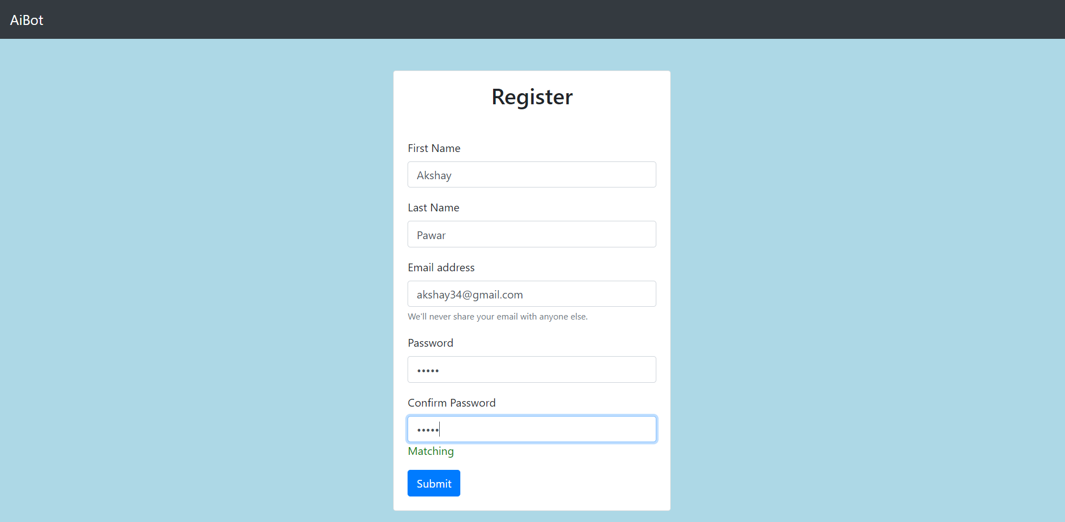

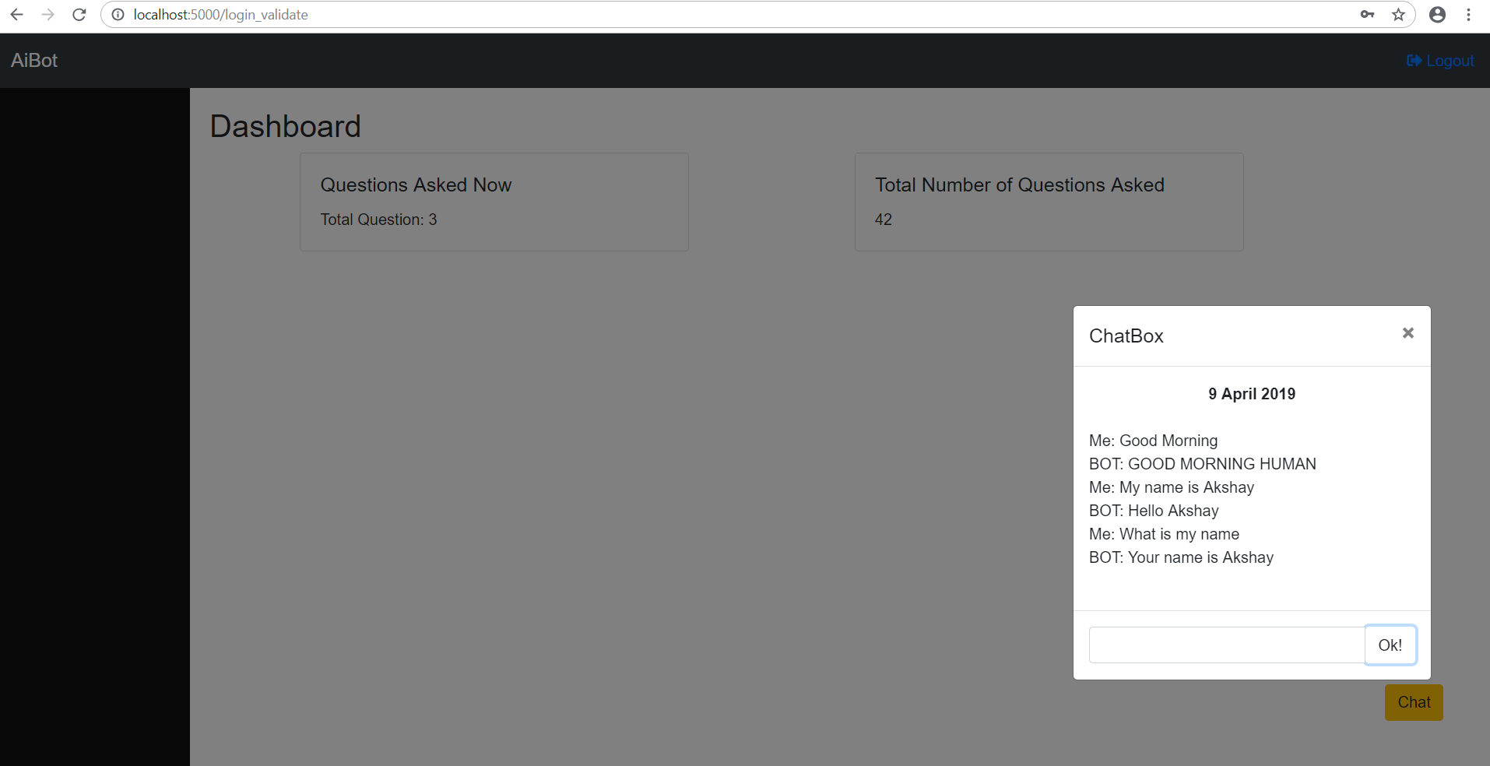

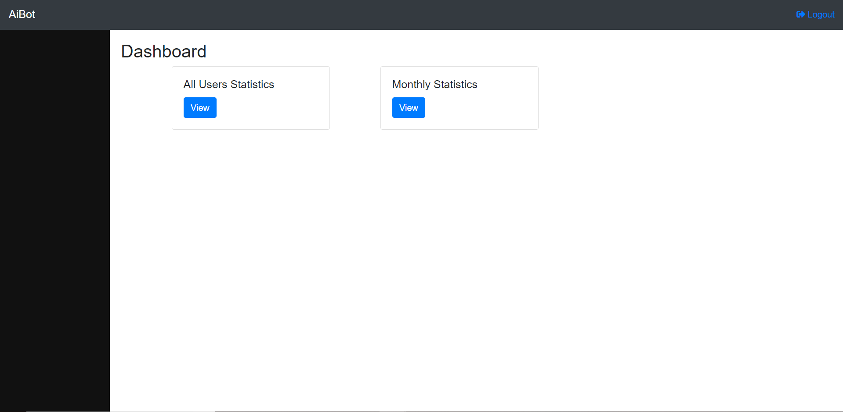

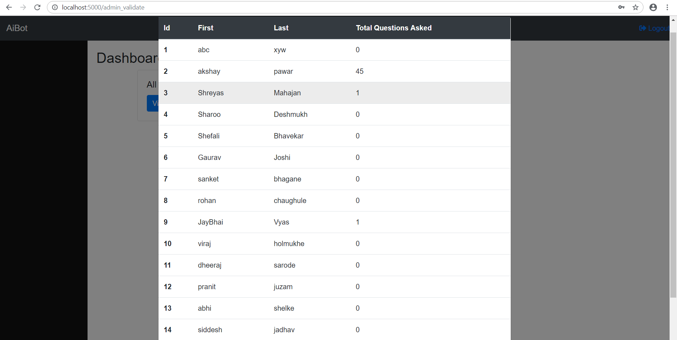

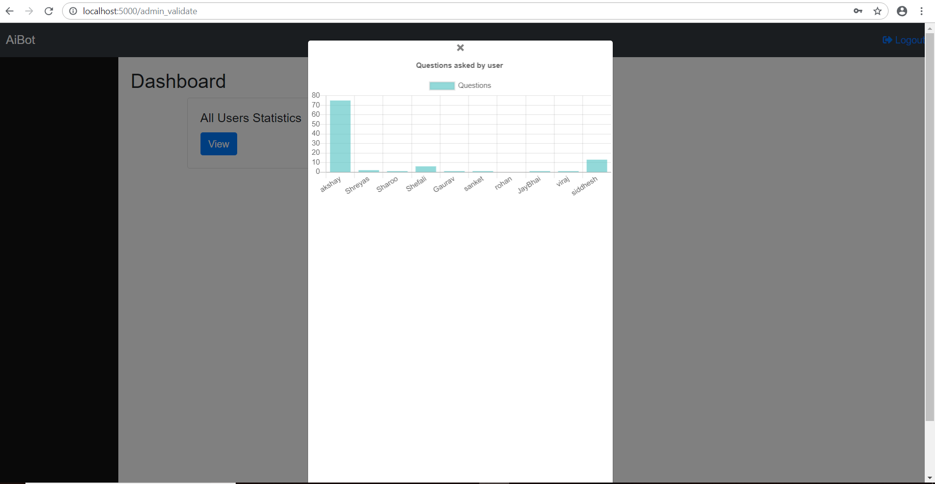

Drawbacks:

1. Since this is a scripted chatbot, which is developed through a questionnaire, which a customer is anticipated to ask , things can get slightly difficult if the question or query requested by an user is not present in aiml files.

Future Enhancements:

1. We can implement some AI Algorithms to figure out the most frequently asked question or the question which was not answered most number of times.
2. We can also consider giving input to our chatbot by voice.
3. We can further generate more efficient reports.

Bibliography:

1. <https://www.tutorialspoint.com/aiml/>
2. <https://www.tutorialspoint.com/flask/>
3. Learning Python by Mark Lutz
4. Mastering Flask Web Development by Gasper Daniel